**Rockhounding tips you need to know before starting a collection**

Story by Grae Gleason

 • 11mo • 2 min read



A pile of colorful polished stones.© Provided by Outdoors Wire

What is rockhounding? Simply put, rockhounding is the hobby of collecting and studying rocks and minerals. Avid rock collectors may refer to themselves as rockhounds. These hobbyists spend their days exploring the land for new gems to add to their collections.

Why do they do it? While everyone enjoys this activity for different reasons, many rockhounds just appreciate the beauty they find in nature. After all, precious stones like diamonds and rubies are rocks. These fascinating geological features are perfect examples of the mysteries awaiting people who explore the outdoors. If you want to discover these mysteries for yourself, start by reading up on some essential rockhounding tips. These quick facts will help you build a stellar rock collection and keep you from making major mistakes.

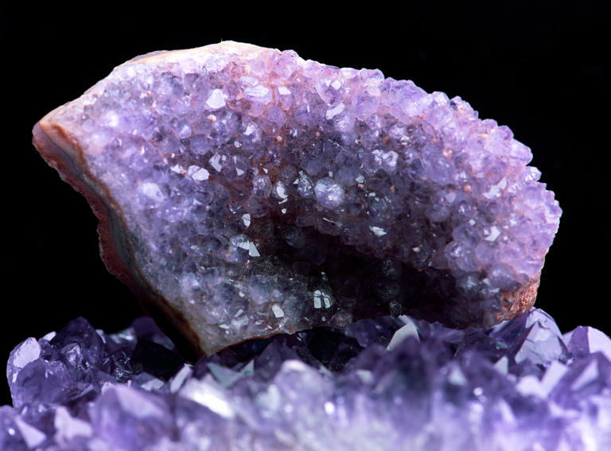

Rules for ethical rockhounding

You’ve got to walk before you can run. For aspiring rockhounds, this means familiarizing yourself with the rock collector’s code.

Currently Rockhounding, a resource site created by two dedicated rock collectors, has compiled a few essential rockhounding rules [here](https://currentlyrockhounding.com/rockhoundingethics/). One key guideline is respecting public and private lands. Public lands include places like national and state parks. Do not take rocks from these areas; the [National Park System](https://www.nps.gov/subjects/geology/permits.htm) prohibits it. Be respectful of private property, too. The last thing you want is an angry stranger approaching you or pressing charges because you went digging around their land.

No matter where you go, do your best to treat the environment with consideration. Ecosystems can be fragile, and your actions have an impact. Don’t use blasting materials to get at rock deposits, and fill any excavation holes you make.

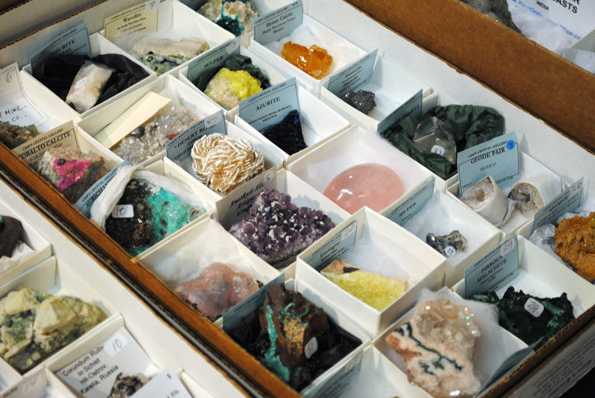

A rock collection full of labeled stones and minerals.© Provided by Outdoors Wire

Photo by Deidre Woollard

How to build an awesome rock collection

With the ethical guidelines memorized, rockhounds can begin building a rock collection. For many, this is as easy as picking up cool stones around the neighborhood. Still, studious rockhounds can elevate their collection with a few basic tips.

As Rachel M. Barker, a geologist with the United States Geological Survey, wrote in “[Collecting Rocks](https://pubs.usgs.gov/gip/collect1/collectgip.html),” a quality collection begins with “properly labeled specimens.” While you may not immediately know what kind of rock you have collected, you can still note important information about the stone. Barker recommends recording where you found the rock soon after collecting it. Later, you can use a rock identification app to determine the exact mineral type. Reddit’s [rockhounding community](https://www.reddit.com/r/rockhounds/) can also help you identify any particularly confusing specimens.

Speaking of the rockhounding community, interacting with fellow rockhounds is a great way to expand your collection. Whether you pursue online or local rockhounding groups, connecting with other collectors can help you discover cool finds from regions far and wide.