RED DAWN AT BEAVER RIM
By Ralph Bishop
This is a story about a petrified “Wood” specimen that by the grace of God and my patience will be around long after I am gone for Paleobotanist to study. Although I am enamored by good stone cutting and most recently involved in sphere cutting with Wes Lingerfelt, my first love will always be specimens that tell a “story”. Walt Lindstrom told me once about the value of specimens; “Ifin you cutt’em up youngster you can’t never putt’em back so think before you cut”.
Last century when I was part owner of the Dryhead Agate Mine on the Wyoming/Montana border I would make my annual summer treks from California to mine the beautiful fortification agate. Taking the I-15 corridor the truck blasted North-Northeaster through the western desert until the truck smelled the freshness of Provo Canyon, Bridal Veil Falls and one of the finest trout fishing streams in the West, an ecological island of life in the promised land of the Mormons. I always stopped there along this stream of life to reflect, relax and listen to the music of fast flowing water before I ascended to the barrens of the Eocene world of Southwest Wyoming. Another relaxing rest was to come as I passed through Green River and Rock Springs. Twin cities so to speak where the residents of each community claimed each other’s “evil” twin residents were the biggest fossil thieves on earth. Their claims were no doubt valid but from my experience the residents of Kemmerer were much worse. They were of course American Patriots who held to the higher law of the Creator and were in fact “Liberating fossils from their oppressors”: the hated Bureaucratic Land Mongers who took their orders from Beelzebub.
From this point traveling North you pass through Eden Valley where the residents of the graveyard out number the living 10 to 1. A short distance later is the one store and a doublewide metropolis of Farson. This is a must stop intersection as the store sells the largest, the best homemade ice cream cones in the entire West…for $1 for a triple scoop. You can’t finish a triple scooper without the ice cream dripping off your elbow.
After this major sugar fix the next place of environmental tranquility was the lithic Crown of America, South Pass on the top of the Continental Divide. Here near the old gold mining camps of South Pass City and Atlantic City was the headwater of one of the tributaries of the Sweet Water River where in the distance could be seen Beaver Rim. When I camped at the top of the world it was springtime, flowers blossomed everywhere and in the highest basin was the biggest beaver dam I have ever seen. It was patrolled by Maw and Paw beaver that sent “Morse Code” as I exited the truck: Slap! Strolling around the pond elicited a Slap! Slap! And as I drew close to the dam face Slap! Slap! Slap! SLAH AP!!
All was peaceful that night and I awoke to a red dawn the next morning. I had thought a great deal about Beaver Rim over the past year because the year before I had seen specimens of a rare type of petrified wood in two rock shops in Lander and I was closing in on Lander.
Stopping at the first rock shop I met the lady who owned the shop and asked her about the rounds I had seen behind the shop the year before. To my horror she pointed to a large wall of shelving covered with bookends. When I didn’t show any interest she took on the demeanor of a rattlesnake and said her bookends were good enough for Walt Wright and they should be good enough for me. I simply stated bookends were not what I was interested in and left before she bit me.
On to the rock shop on the north side of town whose owner was one of the sweetest ladies of the American West and one of my all time favorite characters. She was a true American patriot who “spoke softly and carried a big stick”. She was just the kind of determined Wyoming lady who drove the Suffragettes in Wyoming to victory and the right to vote with a kind word and an iron skillet.
She greeted me at the door of the shop remembering my truck. “Praise God you’ve returned safely”. She always said she would pray for me because I lived in California. We caught up on news of her move to a militia compound with her son. She was ready for Armageddon she said and mentioned that she had watched the movie “Red Dawn” again but she now felt much safer in her new home dug into the mountainside. She had viewed the movie “Red Dawn” where Communist paratroopers landed in a mountain state community very similar to Lander. She took it as serious as did the New Jersey residents when Orson Wells broadcast the War of the Worlds. She said, “I’m ready to fight the forces of Satan”. Opening up a broom closet next to the front door she pulled out an automatic rifle that was about as big as her thin 5’ frame. On the shelf was a stock of banana clips. “Do you know how to use that thing”? I asked. “Sure do,” she said, “we practice at the compound”. It dawned (no pun intended) on me that if there ever were a parachute practice in Lander all hell would break loose. Wanting to change the subject I asked her about “Transitional Palm”. “I think we have sold all we have”, she said. And as it was lunchtime I was invited to lunch of “Prairie Goat (Pronghorn) stew. Pretty gamy it was and took some time to chew but it was filling. I asked her about the “Palm” from Beaver Rim and the conversation turned interesting. For years a very knowledgeable Paleobotanist from Utah had visited her and her husband. He was a good customer. She and her husband grew fond of him but understood little of what he said about the palm. For instance, she thought he called it “Transmission Palm” but she was sure that a transmission was behind the motor in their truck. “So one day”, she continued, “He came by and asked “Father” to take him to the location. She said, “We thought about it, he was such a nice man. But then he made an admission that shocked us to the core”. “What”? I asked. “He admitted he was “That way”. “That way?” What? I asked again. “Well, he said he was a “Fellow”. “Holy Crap”, I thought. Now in academia the word “Fellow” has a much different meaning than it does in “Red Neck America” and being “That Way” was an abomination in the eyes of the Lord. “So” she said, “I told father that I didn’t want him in the desert alone with a “Fellow”. Whether this prestigious gentleman of academia was ever taken to Beaver Rim I do not know but my suggestion to any other academia who is proud of his position of “Fellowship” you might not want to admit you are “that way” when you are in the land of the purple sage.
It was getting on in the afternoon and I wanted to make it up the Wind River that day so I excused myself with a thank you for the “Stick to your ribs” stew. On the way out the door, partially overgrown by sagebrush was a large rock. What’s this? I asked. “Oh, that’s a big “submarine” (Concretion) from Beaver Rim but it’s just a yard rock. The Palm is flat and anyway, It’s too big for the saw”. “Is it for sale? “ I asked. “It’s not very good but we had a hard winter, any money would help”, she answered. “How about $75.00?” I handed her a 100-dollar bill and with great difficulty rolled it up a 2 x 8 plank onto the passenger floorboard of my truck. I bid this lovely flower of the West ado and on to the Wind River.
The “Transmission Palm” has resided until last month by the back door of my home untouched. Now in all her glory she resides in my bedroom, as I am not a “Fellow”. 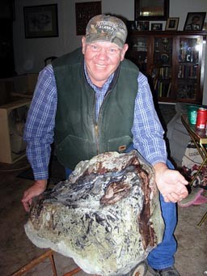
Figure 1. Dick Agin contour polished the specimen

The Specimen:
Rare woods are always interesting because of their linkage in the realm and scope of evolutionary change. One of these “woods” was collected at Beaver Rim, Wyoming by a few local rockhounds. From my understanding this “Transitional Palm” as it was known was a single location material. This material comes from the Wagon Bed Formation that composes the crest of beaver Rim near the Sweet Water River in Sweetwater County, Wyoming. The Wagon Bed Formation is middle to late Eocene in age. It overlies the Wind River Formation Early Eocene) and is unconformable beneath the White River Formation (Oligocene). It is between 130 and 700 feet in thickness and consists of Bentonitic greenish-yellow to yellowish-gray, locally tuffaceous zeolitic mudstones and sandstones in persistent beds along with volcanic sandstones and conglomerates. These beds are rather well sorted and all contain volcanic debris and bentonitic clay (generally a weathering product of volcanic ash). The volcanic debris is particularly abundant at the eastern and western ends of the Beaver Rim. Material in the east was derived from the Yellowstone-Absaroka volcanic field (northwest corner of present day Wyoming) and the material in the west was derived from the Rattlesnake Hills volcanic field (geographic center of present day Wyoming). The specimen is 30” x 27” x 18” and weighs over 200 lbs. It is concretionary in form. A large percentage of the stem is still encapsulated in the greenish opalitic ash matrix. The wood and attending “leaves” and “leaf follicles” are agatized in exceptional detail and exposed by contour polishing on many angles (Photo’s available on-line at www.omsinc.org/archives/Transitional_Palm.pdf

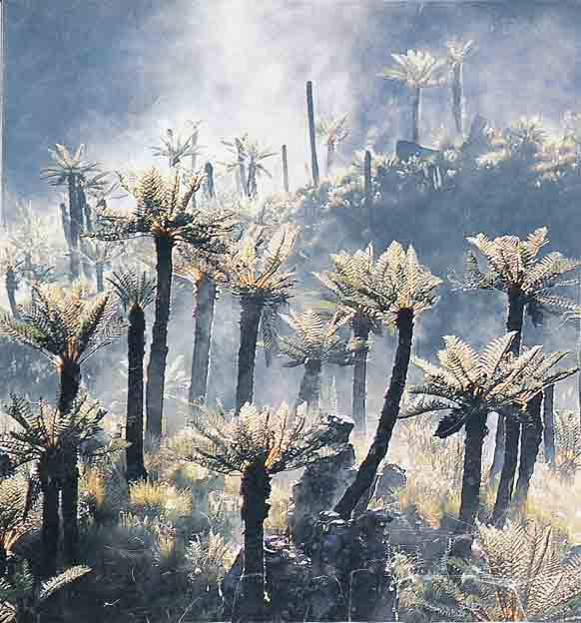
Figure 2. After due consideration of what can be seen in the concretion and paging through countless books this photo comes the closet in my view to the botanical specimen from the Eocene of Beaver Rim. This photo is from National Geographic: “A Cloud Forest” halfway up Mt. Kilimanjaro in Africa. If my memory serves me well they were labeled “Giant Lobelia”.
Many years have passed since I first learned of the “Transitional Palm” and acquired this specimen so further knowledge may have been gained concerning this intriguing material. This specimen may hold a great deal of information that was lost to butchery of previous specimen material.
For those interested in Paleo there will be an upcoming article about the largest Eocene leaf ever found at Douglas Pass, Colorado. (3 feet in diameter).

