**ADOPT-A-HIGHWAY PROGRAM 1993--2022**

Wayne W. Mills, OMS Highway Coordinator

Orcutt Mineral Society has participated in California Department of Transportation’s (Caltrans’s) **Adopt-A-Highway Program** since 1993. (I joined the Society in 1994). A long-time member of our Society, Buck Strader, managed the program from 1993 to 1997 when Marshall Reeves took over. Marshall had the job until he, his wife Glenda, and their two children moved to Oregon in 2008. At that time, I took the job over.

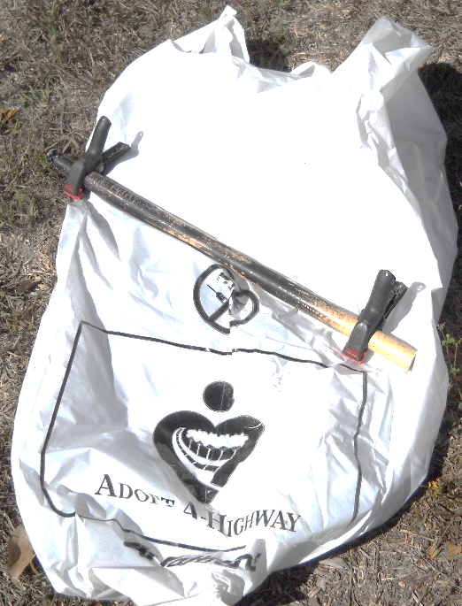

During his tenure as AAH Chair, Marshall devised a clever strategy for carrying two separate trash bags at the same time (one for trash, and one for cans and (plastic) bottles which we recycle. His strategy consisted of a 23” section of ¾” PVC pipe, and 2 small hand clamps with a 1.25” opening capacity. I dubbed this device **“The Marshall Plan”**, and more recently, **“Pick-up Stix”**. To use, simply put the inside edges of two trash bags together and place the pipe inside the edges, then make a couple of rolls until you can place the clamps near either end of the assembly. Now you are ready to pick up trash (after you put the rest of your gear on). **You need:** sturdy shoes and warm enough clothing, and a hard hat, gloves, vest and picker (supplied by OMS). Then you need to know what section you are cleaning.

OMS has been assigned the first two miles of Route 166 East of Highway 101. We have divided our section (which is marked beginning and end with signs bearing our society name) into 4 main sections. These are: **Section one:** the parking area at the southeast corner of Routes 101/166, **Section two:** both sides of the highway from Thompson Avenue east to the first farm driveway and back to the parking lot. Remember to walk facing traffic. **The third section** goes from the second farm driveway on the north side of the highway back to the end of section two and back on the north side of the highway. **Section four** goes from the driveway marking the end of Section 3 to the highway sign marking the end of our clean-up area about 2 miles east of Highway 101.

We begin our clean up at 8:00 AM on the Second Saturday of odd numbered months. (So six clean-ups per year usually.) The clean-up takes about 1.5-2 hours depending on how “dirty” the highway is. In our 29 years of highway clean-ups we have found some interesting things. Note the article “Cleaning-up” in the October, 2022 Ore-Cutts. After our work is done, we often meet at Francisco’s Country Kitchen in Santa Maria for conversation, coffee and treats. Our Wes Lingerfelt, a member of the National Lapidary Hall of Fame, has been doing the clean-ups longer than anyone who currently participates in them. Wes donates an “incentive prize” to each of our after clean-up meetings, and the names of all participants in that day’s clean-up (present or not) are put in a hat. Our waitress Shelly usually draws the winner who is often Mr. Lingerfelt!

**An old saying** that has proven true with our highway clean-ups is: “You never know what you might find”. On previous outings, we have found dozens of “trucker bombs” (water bottles (partly) filled with a strong smelling yellow liquid, as well as “baby bombs”, dirty diapers taped in a roll. Each outing produces an array of aluminum cans, plastic and glass bottles, (we recycle the cans and plastic), Styrofoam and paper food packaging and plastic cups. Individuals have found $50, $20, five and one dollar bills, miscellaneous change, and several lottery tickets (no winners yet). We have found living and dead snakes, squirrels, birds and recently a (not so wily) coyote. We have seen shredded tires, plastic car parts, trailer hitches, and a car roof rack as well as nuts, bolts and chains. On our recent clean-up one member found four classic videotapes that had been smashed and unspooled along the highway. The videos included: “I Love Lucy”, “Children of a Lesser God”, and “The Last of the Mohicans” On a previous clean-up, I found a couple of X-rated videos and two (empty) cans of whipped cream! There have been multiple cell phones found, at least one of which was returned to its’ owner. We have even found a couple of cool rocks along the route. These “treasures” all go to make for an interesting and occasionally profitable outing. You should try it some time!

**In April of 2022,** we received a letter from Caltrans announcing a **“Stipend Program”** which we decided to participate in. We sent in articles about our clean-up, and pictures of the bags we collected, and some of the things that we found. After our May and July Clean-ups, we received a check from the State of California for $500! A pretty nice reward for our clean-up efforts.