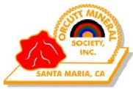

**Sponsored by:**

**Orcutt Mineral Society, Inc.**

**P.O. Box 106,**

**Santa Maria, CA 93456**

**Questions?**

**805-929-2783**

*On the web at:* ***www.omsinc.org***

**ORCUTT MINERAL SOCIETY’S**

**56th Annual Rainbow of Gems Show**

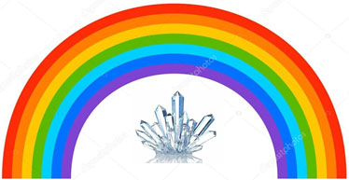

**Rocks-Minerals-Fossils-Jewelry-Dealers-**

**Demonstrations- Displays—Rockhounds**

**NIPOMO HIGH SCHOOL**

**525 N. Thompson Ave., Nipomo, CA**

**AUGUST 2-4, 2024**

**10-5 Friday-Saturday,**

**10-4 Sunday**

**74 outside and inside dealers.**

**ONE-OF-A-KIND rocks, fossils, jewelry and other**

**lapidary-related goods from all over the world. Great prices.**

**Treasure Chest Prizes, kid’s activities—**

**AND Food Vendors**

**FREE PARKING, FREE ADMISSION**

**School District Regulations prohibit**

**alcohol, tobacco and pets on the school grounds**

